Robot V 1.26

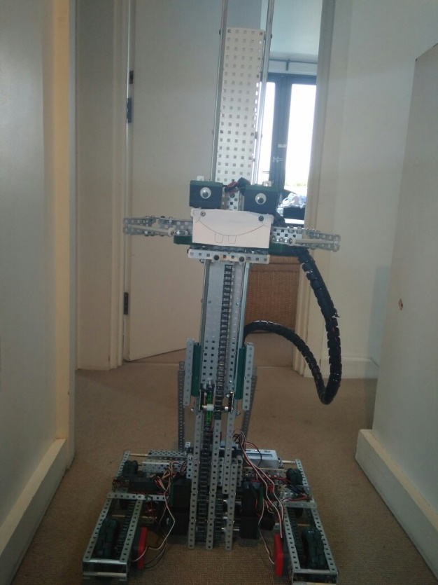

SPECIFICATIONS:

* 6 Motor HS drive
* Two drive chains
* 4 wheels
* Aluminium structure
* 4 motor lift
* Three stage lift
* 2 motor claw

DIMENTIONS:

17.5” * 15” * 17.5 when not extended

**What needs to be changed:**

* Put number plates in a better position
* Remake claw

By Robbie Buxton

20/7/2017 – 19:51

**Overview:**

Most of the day was spend transporting the robot from school to my house because we have decided to work on it over the summer however we did get some word done on the robot. The first thing we did was to properly secure all the cables on the robot to stop them getting stuck in mechanisms and breaking the whole robot which we had experienced a little bit before. We also put some casing around the main wire from the cortex to claw so it doesn’t get suck on parts of the robot and get pulled out with lifting. We also added two line trackers for later in the season when we start to work on autonomous and we finally plugged in all the peripherals so we have no wires dragging along the ground anymore.

**WHAT HAS BEEN CHANGED:**

* Added cosmetics
* Done cable management
* Added two-line tracks
* Plugged in peripherals